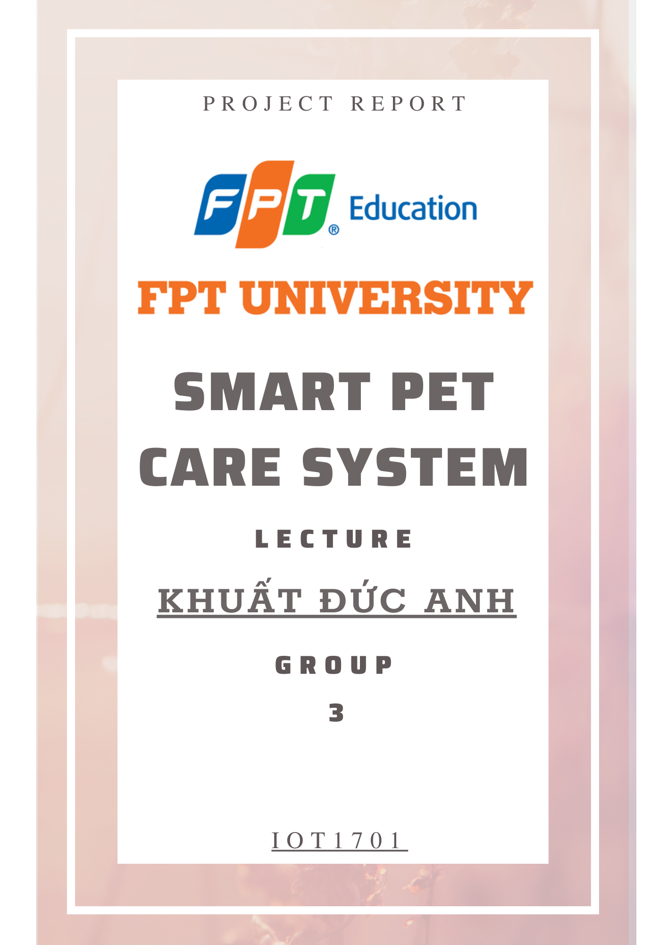

# TABLE OF CONTENTS

**Preamble………………………………………………………………………**

**1. Abstract………………………………………………………………………………………**

**2.** **Introduction……………………………………………………………………………….**

**3. Pet care device…………………………………………………….**

3.1 Some actual problems

3.2 Device architecture diagram

**4. Choosing components…………………………………………………….**

4.1 Ultrasonic sensor

4.2 Infrared sensor

4.3 Relay

4.4 Microcontroller

4.5 Motor control circuit

4.6 Geared motor

4.7 Engine GA N20

4.8 Power

4.9 Cloud

4.10 Camera

**5. Selected equipment…………………………………………………….**

**6. Basic Functions………………………………………………………….**

6.1 Feeding equipment **…………………………………………………….**

6.1.1 Control circuit principle diagram

6.1.2 Control algorithm

6.1.3 Testing and functional evaluation of the system

6.2 Automatic water supply device…………………………………………………….

6.2.1 Electrical cabinet connection

6.2.2 Algorithm diagram

6.2.3 Testing and Optimization

6.3 Remote control toy module…………………………………………………….

6.3.1 Circuit Connection

6.3.2 Control function

6.3.3 Pros and cons

**7. System Deployment…………………………………………………….**

**8. Application for control and monitoring on the phone………………**

8.1 Controls

8.2 Observe

**9.Evaluation**

**10. Conclusions and development directions……………………**

**11. Project Plan management…………………………………………………….**

**12. References…………………………………………………………………………**

# List of figure

1. Figure 1.IoT Architecture
2. Figure 2. IoT system diagram
3. Figure 3. Architecture of Smart Pet Care System
4. Figure 4. Device structure
5. Figure 5. Circuit map of Selection Feeder
6. Figure 6. Processing Flow of Selection Feeder
7. Figure 7. Algorithm diagram of Selection Feeder
8. Figure 8. Cat food
9. Figure 9.The principle of the screw feeder machine
10. Figure 10. Feeding equipment
11. Figure 11. Circuit map of Automatic Drinker
12. Figure 12. Processing Flow of Automatic Drinker
13. Figure 13. Algorithm diagram of Automatic Drinker
14. Figure14: Drinking water device
15. Figure 15. 1st water level test results
16. Figure 16. 2nd water level test results
17. Figure 17. Circuit map of Remote Control Toy
18. Figure 18. Processing Flow of Remote Control Toy
19. Figure 19. Algorithm diagram of Remote Control Toy
20. Figure 20. Principle of winch machine
21. Figure 21. Equipment for cats to play
22. Figure 22.Diagram of Smart Pet Care System
23. Figure 23. System Algorithm Diagram
24. Figure 24. UI in Smart Pet Care APP
25. Figure 25.Water level warning on the Blynk app
26. Figure 26. Video from ESP32

# 

# List of tables

1. Table 1: Ultrasonic sensors
2. Table 2: infrared sensor
3. Table 3: Relay
4. Table 4: Microcontroller
5. Table 5: Motor control circuit
6. Table 6: Geared motor
7. Table 7: GA N20 DC motor
8. Table 8: Choosing a source
9. Table 9: Cloud
10. Table 10: Cam
11. Table 11. Experimental results table
12. Table 12. Experimental results table

# 

# 1.Abstract

The research foundation of the intelligent system for cats stems from the growing need for innovative solutions in pet care, especially when in modern society owners cannot always be by their side, care for them. Recognizing the importance of creating a cat-friendly environment, this study aims to explore the potential of integrating advanced technology into the cat care system, supporting owners in their care, from far away. The research objective is to design and develop an intelligent system that combines technology, sensors and connectivity to provide a safe, interactive living space for cats. The intelligent system is combined with motion sensors,feeding,observing , automatic drinking systems, and interactive elements. Deploying smart systems shows significant benefits, with IoT you can remotely monitor pets, track activity and schedule meals, and alert water levels via mobile devices to make sure the device is still working properly. [10] This project aims to provide a solution in improving the quality of life for cats, taking care of pets and giving owners peace of mind while on business trips while providing cats with a comfortable living space and wonderful.

**Key words** : Internet of Things, Cat Care System, Remote control, Monitoring

# 2. Introduction

New wireless communication-based technologies have come to us in the 21st century. These technologies have already begun to transform every aspect of our existence. The development of the smartphone sparked the biggest revolution. From there, it is possible to have more advanced technology with a wider range of functions. Since smartphones are now carried by most people, they are working by connecting to them. The Internet of Things (IoT) is a new technology that is currently being catalyzed by smartphones. IoT really refers to all the technologies needed to create a wireless service that processes data collected from several sensors, not just one specific technology. Therefore, IoT is a new idea for the Internet in the 21st century.[1,2]

In 2000, the term IoT was apparently coined by a member of the RFID developer family who called tag information discovery by traversing an Internet address or database entry corresponding to a specific RFID. Since that time, people have sized up the phrase “Internet of Things” to refer to the general interconnection of things, especially with readable, identifiable, localizable, localized objects. can only be and can be controlled via the Internet. All objects include electronic devices and products of higher technological development, but we usually do not think of it as electronic, such as food, clothing, documents, books, landmarks , boundaries and monuments, and everything in our lives. In [5], Kranz et al. developed various prototypes to explore new ways for human-computer interaction to realize the device of IoT. For example, they created several prototypes to demonstrate context-aware kitchen gadgets, including cutting boards with tools, audio and visual-based activity detection systems, sensor-based activity recognition, and more. Body-worn variables and sensor-enhanced blades can infer context and activities happening in the kitchen. In addition, smart environments can learn, recognize, and use behavior to provide many new services to family members. In addition, the authors used policy-aware object design to develop health and safety-aware smart objects as an IoT device, acting as a smart bucket with embedded storage rules for different chemicals. Depending on the temperature, vibration and relative distance of the bins, it will notify workers of safety violations and prompt them to take appropriate action [6].

Domestic cats are descended from wild cats. Cats are animals that are kept a lot in households. In the United States, more than 47 million households own cats. But perhaps not many people know about the history of the origin of cats. Originated from wild cats. In fact, cats have been our friends for a long time, scientists have found evidence that cats began to be domesticated about 10,000 years ago[9].

"The Internet of Things can make pet care smarter by connecting devices to monitor their health, activity and provide better services for them." - Ericsson.[7] A smart cat breeding system is a convenient solution for cat owners, combining IoT technology and smartphones to care for and manage pets. With the development of technology, smart cat feeding systems have become an effective way to monitor and interact with cats even when they are not present. The smart cat farming system is equipped with sensors and control devices integrated in a system linked via the Internet. The owner can easily control and observing the cat's activity, health and development through a smartphone application. Through infrared sensors, ultrasonic sensors. This allows for timely detection of any unusual signs of the cat's health. In addition, the intelligent cat feeding system also helps to manage the cat's nutrition by automatically providing the right food and dosage. Owners can set a feeding schedule and ensure that the cat is given the right nutrition. Allows the owner to call and interact with the cat through a toy that can be lowered and retracted when the owner cat wants to play. This helps maintain contact and ensures the cat doesn't feel lonely when the owner is away.

In this study, we propose a pet care system that can feed pets while owners are away, monitor their whereabouts and health, and even allow owners to control games from their phones their intelligence. The proposed system is different from others in that it is built on IoT technologies, making extensive use of wireless communication and sensing technology. We have now developed the following use. Feeding food intake by website and mobile app, cat movement with ESP32 Camera, remote control of cat toys and control via Blynk app

# 3. Pet care device

## 3.1 Some actual problems

Due to the low birth rate in Taiwan, researchers should focus more on rapid changes in lifestyle. Some studies show that when people go to the park on the weekend, more of them walk the dog than hold the baby. According to a June 2006 report from Pet Care Services in the United States, American pet care services generated approximately $363 million in revenue in 2005. The service's annual growth rate This will reach 6% in the future [3]. In addition, Eastern Europe and Asia will become potential markets for pet services. Meadows and Flint point out that low birth rates and weakened bonds between family members have increased the importance of pets [4], leading to a corresponding increase in pet services.

As Taiwanese society continues to have low birth rates and an aging population, more and more people consider their pets as family members. This trend is reflected in pet-related products and market activities. For example, some pet owners have started taking their pets with them when traveling. A report from the 2010 Asia Pacific Pet Economics Conference [8] mentioned that the pet industry has grown significantly in recent years. They forecast that the market will double in the next two years. According to previous research [9], families in Taiwan raised 1,630,000 dogs in 1999. However, this number dropped to 1,320,000 in 2007. On average, each family had 1.55 dogs. % of dog owners. In contrast, there were only 195,000 cats in homes in 2001 and the total grew to 281,000 in 2006. This is a 4.4% increase per family. Based on these Fig.s, the average family has 1.6% cats. More than 166,000 babies were born in Taiwan in 2009, down more than 20,000 from the previous year, according to a report by the Economic Development and Planning Council. As such, Taiwan's fertility rate has dropped to the lowest in the world at 8.29%, with each woman giving birth to less than one child in her lifetime. The average family has more pets than children. This means that the demand for pet products will increase rapidly and household spending on pets will exceed spending on children. The pet industry and pet owners have slowly begun to realize the need for automated farming devices.

IoT today has grown to become very popular. As a result, countless models of IoT systems are created, and each of them will have different common and unique characteristics. The following are two fairly common system models:

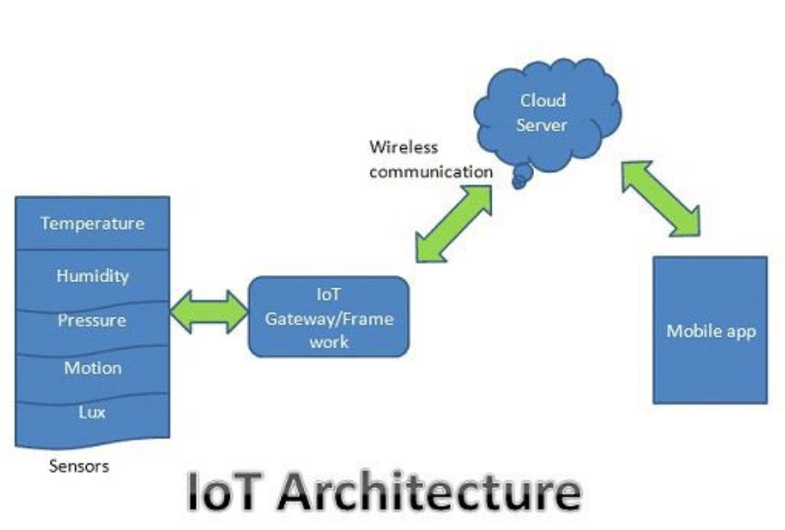

Figure 1.IoT Architecture

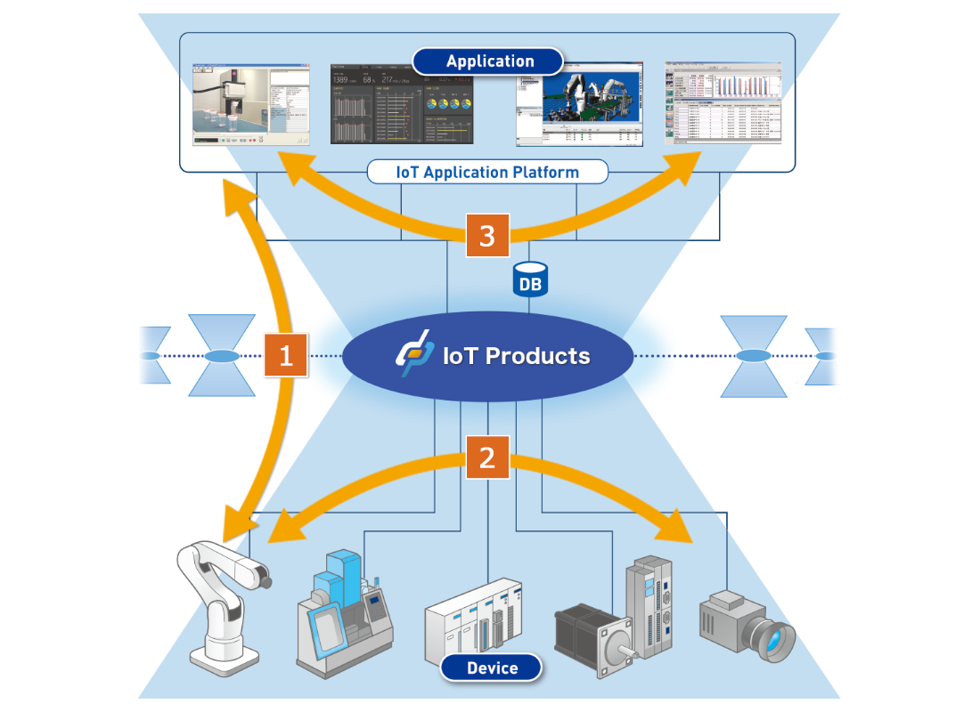

Figure 2.IoT Architecture

## 3.2 System architecture

Based on the above systems, an intelligent pet care system is proposed and described in Figure 3 and Figure 4. As you can see in the picture, the main parts of the smart pet care system consist of 5 components.

Figure 3. Architecture of Smart Pet Care System

Device 1: Connecting to a Wi-Fi Router - This device is capable of connecting to a Wifi network through a built-in Wifi interface or Wi-Fi module. The task of this device is to collect and send data from sensors or other data sources to a cloud server.

Device 2: Capable of connecting to a Wi-Fi network. It can send image or video data to a cloud server or transmit it directly to other devices in the local network via a Wi-Fi connection.

Cloud server: Data from device 1 and device 2 is sent to a cloud server. This cloud server can be an application server or a cloud service server, where data is stored, processed and managed.

Application: Data from a cloud server is streamed down to an application. The application can be a mobile application or a web application, where the user can access and interact with the data collected from the device.

Through this architecture diagram, data from devices is sent to the cloud server, then from the server, the data is transmitted down to the application for display and processing. This allows users to monitor and interact with data from devices through the app.

Once we have the system architecture in place, we will dive into the structure of the device. As you can see in the figure, the main parts of the first device.

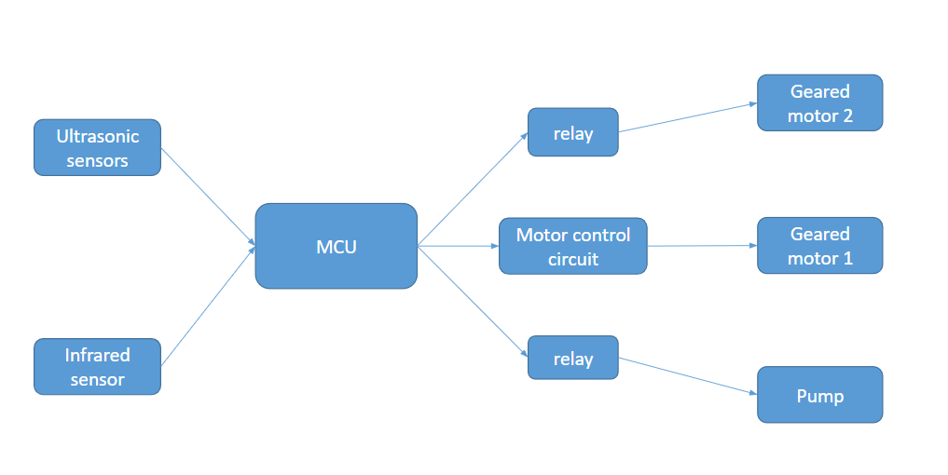

Figure 4. Device structure

Each component has its own platform, as shown in the figure, and each platform has a variety of sensors built into them. These items are made to be connected in a home network based on WiFi WLAN. Although WiFi is one of the connectivity technologies, there are others as well. Other technologies, such as LTE mobile communication technology, may be used. Typically, smartphones can be used to check the health of a smart pet care system and change how each component in the system responds to commands. The smartphone can be used directly in both 3G and 4G mobile networks and WLANs.

# 4. Choosing components

Based on the above requirements and system architecture, we tested a variety of sensors and devices to find the ones that best fit the requirements. Here are some of them

## 4.1 Ultrasonic sensor

The HC-SR04 ultrasonic sensor, with its low cost and accurate distance measurement capabilities, is an ideal device for projects due to its suitability and efficiency. With the ability to detect and measure distance using ultrasonic waves, this sensor can be applied in many fields such as robot control, precision measurement in automated systems, or even in the construction of security and surveillance systems. In particular, with its energy-saving features and easy connection to microcontrollers and electronic boards, the HC-SR04 sensor has become an important and popular tool in the DIY community. homemade) and embedded IoT systems.

**Table 1: Ultrasonic sensors**

| Ultrasonic Sensor | HC-SR04 | JSN-SR04T | MB1010  LV-MaxSonar-EZ1 | LV-MaxSonar-EZ3 |
| --- | --- | --- | --- | --- |
| Number of pins | 4 | 4 | 4 | 4 |
| Operating range | 2- 400 cm | 25 – 400 cm | 20 -765 cm | 30 -540cm |
| Transmitting angle | 15 degrees | 30 degrees | 42 degrees |  |
| Receiving angle | 60 degrees | 45 degrees | 15 degrees |  |
| Resolution | high | high | high | high |
| Price | 30 - 50k | 100 – 150k | 400 - 500k | 300 - 500k |

## 4.2 Infrared sensor

The HW-488 sensor was chosen for some notable reasons. First of all, when compared to other motion sensors with a large range of 1.5m to more than 3m, they proved unsuitable for a cat system. This is probably because too wide a range can cause disruption and inconvenience.

In contrast, the HW-488 is an infrared sensor with a short range of 2 cm to 25cm, allowing it to capture movements and distances in close range. This is useful in monitoring and interacting with cats, where activities take place on a small scale.

Notably, the HW-488 also has a built-in anti-interference feature, making it resistant to the effects of strong light in the room. This ensures that the sensor remains reliable even when the surroundings are well-lit without being affected by interference from the light.

As such, the HW-488 is the ideal choice for equipment, with its short range, anti-interference ability and the ability to accurately monitor close movements.

**Table 2: infrared sensor**

| Motion-activated thermal sensor | PIR SR505 Mini | Infrared Obstacle Sensor HW-488 | PIR HC-SR501 |
| --- | --- | --- | --- |
| Operating voltage | 3.3V – 5V DC. | 3 – 6VDC | 3.8V - 5VDC |
| Number of pins | 3 | 3 | 3 |
| Trigger |  |  | 30 seconds can be adjusted using a variable resistor |
| Scanning angle |  |  | 360-degree cone angle |
| Detection range | 2 ~ 5 cm | 2 – 25cm | 6m |
| Price | 11k | 18k | 22k |

## 4.3 Relay

When choosing a relay, the decision to choose a 5V relay is made based on a number of benefits and in accordance with the requirements of the system. It is worth noting that the motor and pump in the system use voltages from 3V to 9V. Therefore, choosing a 5V relay is an appropriate choice because the operating voltage of the relay will be compatible and provide a stable power supply for the motor and pump.

Selecting a 5V relay provides assurance that the relay will operate efficiently within the required voltage range and avoids other problems such as overvoltage or undervoltage resulting in unreliable operation or motor damage. and pump.

Besides, choosing a 5V relay is also convenient because it is compatible with the 5V mains power supply available in the control system. This reduces the complexity and cost of supplying power to the relay, as no additional voltage regulation or transformer circuitry is required.

**Table 3: Relay**

| Relay | 1 Channel Relay Module - Low Level Trigger - 5VDC | 1-Channel Relay Module with Opto Isolation, High/Low Level Trigger (5VDC) | 1-Channel Relay Module with Opto Isolation, High/Low Level Trigger (12VDC |
| --- | --- | --- | --- |
| Number of entries | 3 | 3 | 3 |
| Number of exits | 3 | 3 | 3 |
| Operating voltage | 5VDC | 5VDC | 12VDC |
| Maximum current | 10A | 10A | 10A |
| Operating principle | low-level | low-level | low-level |
| Price | 30K CZK | 22k | 22k |

## 4.4 Microcontroller

The choice of ESP8266 is a decision made based on many important factors. The ESP8266 is a Wi-Fi integrated circuit that allows easy connection to a Wi-Fi network and data transmission over the wireless network. This creates convenience and flexibility in remotely controlling and monitoring the device.

Meanwhile, ESP8266 also supports connection to Blynk Cloud - a popular and powerful remote control platform. The integration with Blynk Cloud allows users to easily create custom user interfaces and control the device remotely via the mobile app or web interface. This increases the interoperability and remote management of the system.

Not only has strong networking features, ESP8266 was also chosen because its price is considered stable and suitable for the project. This reduces costs and ensures savings in total system deployment.

Finally, ESP8266 provides enough pins to connect all devices in the system. This ensures flexibility in connecting and communicating with different components of the device.

In short, choosing the ESP8266 is a reasonable decision based on its Wi-Fi connectivity, integration with Blynk Cloud, stable price and the number of connection pins that fully meet the system's requirements. This brings convenience, flexibility and savings in project implementation.

**Table 4: Microcontroller**

| MCU | ESP8266 | Arduino Uno R3 | Raspberry Pi 4 Model REMOVED |
| --- | --- | --- | --- |
| GPIO | 17 pins | 14 pins | 40 pins |
| CPU | Tensilica L106 32-bit RISC microcontroller | AVR 8-bit Atmega328P microcontroller | Broadcom BCM2711, quad-core Cortex-A72 (ARM v8) 64-bit SoC |
| Processing speed | 80 MHz | 16 MHz | 1.5GHz |
| Ram | 80KB | 2KB | 1GB, 2GB or 4GB  LPDDR4-3200 SDRAM (option) |
| Internal memory | 4MB | 32KB | Micro SD card |
| Communication | Wifi, UART, SPI, I2C, ADC | UART, SPI, I2C, ADC | Wi-Fi 802.11ac and Bluetooth 5.0 |
| Price | 58KZK | 250K CZK | 3m-4m5 |

## 4.5 Motor control circuit

Motor control circuit selection is made based on the following factors. Firstly, the motor control circuit is capable of operating in the voltage range from 5V to 12V, in accordance with the operating voltage requirements of the yellow gear motor with voltage from 3V to 9V. This ensures that the control circuit can provide a consistent and stable power supply to the motor.

In addition, the motor control circuit also provides the ability to adjust the direction of motor rotation. This is useful in controlling and achieving different operating modes of the yellow geared motor. The ability to adjust the direction of rotation increases the flexibility and application of the control system.

The choice of the motor control circuit is considered reasonable because it provides the right power for the motor and has the ability to adjust the direction of rotation, two important factors in effectively controlling the yellow geared motor.

**Table 5: Motor control circuit**

| Motor control circuit | The L298 DC Motor Driver Control Circuit | The TB6560 Stepper Motor Control Circuit | The BTS7960 43A High-Power DC Motor Control Circuit |
| --- | --- | --- | --- |
| Operating voltage | 5~30VDC | 10-35VDC | 6 ~ 27VDC |
| Maximum power | 25W single-ended | 3 | 3 |
| Current | max 2A | max 3A | 43A (Resistive load) or 15A (Inductive load) |
| Size | 43x43x27mm |  | 40 x 50 x 12mm. |
| Price | 31k | 151k | 85k |

## 4.6 Yellow gear reduction motor

Choosing the yellow geared motor was decided quickly due to its advantages. First, one of the reasons for choosing this motor is its low cost. This reduces costs and creates savings in project implementation. For the purpose of only performing the function of lowering the toy necessary when letting the cat play, without using a complicated or expensive motor, the gold gear motor is a suitable and economical choice.

Besides, the yellow gear motor only performs a specific function, that is to lower the toy and drag it when needed. Choosing a motor that is simple and only works within a certain range of functions is suitable for the requirements of cat play. This reduces complexity and ensures efficiency in performing the specific task of the engine.

In summary, choosing a yellow gear motor is an appropriate decision, based on its low cost and ability to only perform the function of lowering the toy when necessary. This makes it economical and efficient for cats to play safely and happily.

**Table 6: Geared motor**

| DC geared motor | Gold 2-Shaft 1:48 DC Geared Motor | GA12 N20 DC Geared Motor | JGB37-550 DC Geared Motor |
| --- | --- | --- | --- |
| Number of pins | 2 | 2 | 2 |
| Operating voltage | 3-12VDC | 0~12VDC | 12VDC |
| Speed | 125 rpm 3VDC  208 rpm 5VDC | 75RPM - 200RPM | 31RPM - 125RPM |
| Traction force |  | max 1kg.cm | 25KG.CM- 120KG.CM |
| Size | 64 * 19 * 22.6mm | 37 x 12mm |  |
| Price | 20k | 60k | 195k |

## 4.7 Engine GA N20

The GA N20 motor was selected due to its several advantages. The fact that this motor is small and compact, is in line with product design requirements. This saves space and is easy to integrate into compact and space-constrained applications.

Meanwhile, the GA N20 motor has an operating voltage between 3V and 6V. This makes it suitable for conventional power supplies and is easily integrated into existing power supply and control systems. Selecting a motor with the right voltage range helps to ensure stable and efficient operation of the product.

In conclusion, the choice of the GA N20 motor is considered a reasonable choice in product design, thanks to its suitable small size and operating voltage from 3V to 6V. This offers flexibility and convenience in integrating motors into applications with limited space and power requirements.

**Table 7: GA N20 DC motor**

| DC geared motor | Gold 2-Shaft 1:48 DC Geared Motor | GA12 N20 DC Geared Motor | JGB37-550 DC Geared Motor |
| --- | --- | --- | --- |
| Number of pins | 2 | 2 | 2 |
| Operating voltage | 3-12VDC | 0~12VDC | 12VDC |
| Speed | 125 rpm 3VDC  208 rpm 5VDC | 75RPM - 200RPM | 31RPM - 125RPM |
| Traction force |  | max 1kg.cm | 25KG.CM- 120KG.CM |
| Size | 64 * 19 * 22.6mm | 37 x 12mm |  |
| Price | 20k | 60k | 195k |

## 4.8 Power

First, choosing a 5V source connected through the USB port is suitable for the ESP8266 because the micro USB connection wire is used to load the program and supply power to this circuit. This creates convenience and flexibility in powering the ESP8266.

In addition, other devices in the system require a power supply of 3V to 9V. With a 5V 2A power supply, it is a reasonable choice as it provides the right voltage and meets the needs of other devices. At the same time, the 2A current also ensures that the system is supplied with enough power to operate stably and ensure good performance.

Choosing a 5V 2A power source is a reasonable choice based on the ability to connect via USB port, meeting the power requirements of ESP8266 and other devices in the system. This provides convenience, compatibility and ensures good performance for the entire system.

**Table 8: Choosing a source**

| Power source | 5V | 12V | 5V |
| --- | --- | --- | --- |
| Current | 1A | 3V | 2 A |
| Plug | round |  | USB |
| Price | 26k | 70k | 60k |

## 4.9 Cloud

Using the Blynk application is one of the reasonable options with its many advantages. Blynk provides a simple and friendly user interface that allows users to create custom interfaces to remotely control and monitor devices via mobile phones or computers.

In addition, Blynk allows users to create connections and control devices remotely via the Internet. This offers flexibility and convenience, allowing users to manage and control devices even without being physically present in the field.

Blynk also supports integration with a variety of hardware and communication platforms, including Arduino, ESP8266, Raspberry Pi, and many more microcontrollers. This creates compatibility and flexibility in integrating Blynk into existing projects and systems.

Another advantage of Blynk is security. Blynk uses secure encryption and authentication methods to ensure that devices and data are protected in transit.

Finally, Blynk provides a large community and community support. Users can share and search for projects, UI samples, and usage in the Blynk community. This creates knowledge sharing and support among members of the community.

**Table 9: Cloud**

| Cloud | Blynk | Thinkspeak | AWS |
| --- | --- | --- | --- |

## 4.10 Camera

Here are a few reasons why the ESP32 camera was chosen:

Built-in Wifi: ESP32 is a development module based on ESP32 microprocessor from Espressif Systems, supporting built-in Wifi connection. This allows you to easily connect and control the camera via a Wi-Fi network.

Powerful performance: ESP32 is equipped with a dual-core processor and high operating frequency, which enables powerful processing and is compatible with resource-intensive applications, including image processing from cameras.

Multi-function: The ESP32 camera is not only an ordinary camera but also integrates other features such as networking, microprocessor, GPIO and other communication protocols. This allows you to develop complex applications and connect with other devices and systems.

Easy development support: ESP32 has a large and active community of developers and users. You can find many documents, examples and open-source code related to the ESP32, which will help you quickly get around and develop the camera application you want.

Reasonable price: ESP32 is designed to be an affordable, economical solution for smart camera applications and other IoT projects.

**Table 10: Cam**

| ORANGE | ESP32-CAM | M5Stack PoE Camera | LilyGO T-SIMCAM |
| --- | --- | --- | --- |
| Voltage | 5V | 5V | 3.3V |
| PSRAM/SRAM | 8MB/512KB | 8MB/512KB | 8MB/512KB |
| Supports Hardwired TCP/IP Protocols | UART, SPI, I2C, PWM, TCP | IP, TCP, UDP | TCP, UDP, ICMP, IPv4, ARP, IGMP, PPPoE |
| Pixel Size | 2.2 m x 2.2 m | 2.2 m x 2.2 m | 1.622 m x 1.2 m |
| Wifi/Bluetooth | provide support | provide support | provide support |
| Product size | 27mm x 40.5mm x 4.5 mm | 64mm × 24mm × 18mm | 78mm x 36mm x 16mm |
| Price | $11.77 | $39.90 | $16.04 |

# 5. Selected device

Ingredients:

| **Parameter** | **Property** | **Unit** |
| --- | --- | --- |
| Operating voltage | 5 | DRAW |
| Network | Wifi, 4G |  |
| Connect ability | WIFI |  |
| Processor | ESP8266 | 1 board |
| Range | 20-3000 | square meter |
| Sensor,Circuit,Engine | movement sensor, ultrasonic sensor, DC motor, submersible pumps, push device | 1 |

After going through the process of testing and comparing, here are the devices selected for the project

| Device | Picture | Quantity |
| --- | --- | --- |
| ESP8266 NodeMCU |  | 1 |
| HW-488 infrared sensor |  | 2 |
| Ultrasonic sensor HC-SR04 |  | 1 |
| Yellow geared motor |  | 1 |
| Geared motor GA N20 |  | 1 |
| Mini pump 5v |  | 1 |
| Relay 5v |  | 2 |
| ESP32-CAM-MB |  | 1 |

# 6. Basic Functions

## 6.1 Feeding devices

### 6.1.1 Control circuit principle diagram

Obesity is one of the biggest health challenges that lead to reduced life expectancy and is associated with cardiovascular-respiratory, orthopedic, endocrine and oncological disorders, and disorders in humans and dogs [11]. Obesity is not a single disorder but rather a heterogeneous group of conditions with multiple etiologies determined by the interaction of genetic, environmental and psychosocial factors acting through various factors. physiological mediators of energy absorption and expenditure [12]. Reviewing the 21st-century busy lifestyle, emotional attachment with the companion animal, problems associated with the pet care industry, available market products and related research, it is found that the true healthy value. (13) Pet should have optimal sleep, activity, dry food intake, and water intake. (14) Calories consumption should be more than the resting energy requirement (RER) as recommended by the American animal hospital association (AAHA) nutrition and weight management guidelines for dogs and cats [15].

The optional feeder shares similar basic functions as market-available products. However, its distinguishing features are enhanced communication and sensory capabilities.Equipped with a relay, DC motor, our feeder drops the feed, sends data to the app and works based on programmed intervals. Users can customize feeding schedules and adjust portion sizes based on the weight of the food. Surveillance is facilitated through the user's smartphone. Automatic feed drop is implemented using the ESP8266 MCU, depicted in image 2. The smartphone app allows users to monitor the feeding machine's status.

Figure 5. Circuit map of Selection Feeder

The principle of operation of the device is quite simple as shown in the figure below. This contributes to making it easier for users to use.

**How selective feeding works**







Figure 6. Processing Flow of Selection Feeder

### 6.1.2 Control algorithm

The algorithmic principle of the device is also quite simple. Blynk will receive data through its generated nodes, then will respond accordingly with the value of each of those nodes.











TRUE



FALSE





Figure 7. Algorithm diagram of Selection Feeder

### 

### 

### 

### 6.1.3.Testing and evaluating system functionality

Mister Donut T2 Indoor Cat Food (seeds only)

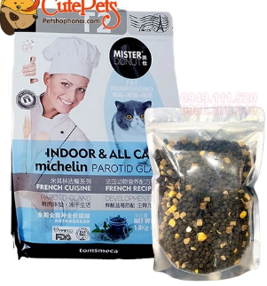

Figure 8. Cat food

Twisted screw (diameter 2cm)

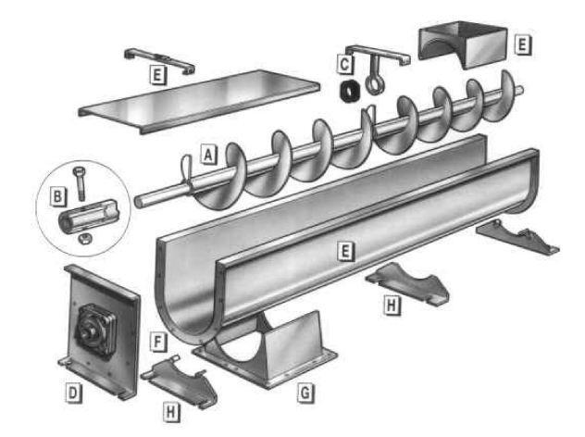

Figure 9.The principle of the screw feeder machine

A helical screw is utilized to connect to the motor through a 3*8mm coupling. This screw is then inserted into a PVC pipe with a diameter of 21mm. By placing the food inside the tube, upon activating the motor, the helical screw rotates, gradually pushing the food out.

Figure 10. Feeding equipment

To determine food quantities within specific time intervals, predetermined release durations were established. Experiments measured food amounts during each period. For example, in a 5-second experiment (10 trials), the mean value determined the 5-second food quantity. Similar procedures were applied in a 10-second experiment (10 attempts).

**Table 11. Experimental results table**

| Number of tests | Feed intake time(s) | Amount of food returned (g) |
| --- | --- | --- |
| first | 5 | 17.2 |
| 2 | 5 | 17.2 |
| 3 | 5 | 18.0 |
| 4 | 5 | 17.3 |
| 5 | 5 | 17 |
| 6 | 5 | 16.6 |
| 7 | 5 | 16.8 |
| 8 | 5 | 17.2 |
| 9 | 5 | 16.5 |
| ten | 5 | 17.3 |
|  |  | AVG = 17.1g |
| Number of tests | Feed intake time(s) | Amount of food returned (g) |
| first | ten | 34.2 |
| 2 | ten | 34.5 |
| 3 | ten | 33.2 |
| 4 | ten | 33.3 |
| 5 | ten | 33.8 |
| 6 | ten | 33.9 |
| 7 | ten | 33.9 |
| 8 | ten | 33.8 |
| 9 | ten | 34.0 |
| ten | ten | 33.4 |
|  |  | AVG = 33.8g |

Experiment 1 dispensed an average of 17.1g within 5 seconds (approximately 3.42g per second). Experiment 2 yielded an average of 33.8g within 10 seconds (about 3.38g per second). In minimizing errors, the aim was to identify the value with the smallest margin. Thus, an approximate rate of 3.4g per second was expected, based on the average of 3.42g and 3.38g.

To ensure accurate results, additional tests were conducted by reversing the process. Duration measurements for dispensing 10g, 15g, and 20g revealed 1 second equivalent to 3.4g. Consequently, 10g required 3 seconds, 15g necessitated 4.4 seconds, and 20g demanded 5.9 seconds.

Based on these findings, the implemented time values in the code will verify the desired food amount.

**Table 12. Experimental results table**

| Number of tests | Feed intake time(s) | Amount of food returned (g) |
| --- | --- | --- |
| first | 3.0 | 10.2 |
| 2 | 3.0 | 10.2 |
| 3 | 3.0 | 10.0 |
| 4 | 4.4 | 15.5 |
| 5 | 4.4 | 15.0 |
| 6 | 4.4 | 14.9 |
| 7 | 5.9 | 20.1 |
| 8 | 5.9 | 20.4 |
| 9 | 5.9 | 20.4 |

As observed, the calculation of 1s = 3.4g demonstrates reasonable accuracy, with an error margin of no more than 1g. Hence, for different cats and varying amounts of food, we can adjust the feeding time accordingly.

## 6.2. Automatic water supply device

### 6.2.1 Electrical cabinet connection

The amount of water to drink depends on a number of factors such as atmospheric temperature, type of feed (dry, wet or roughage), body weight and animal activity. These factors are considered while we build the device. However, when pet owners are away from home for a long time, it is difficult for them to give their pets a drink[21]. IoT technology has been used to design automatic pumps for the convenience of cat owners.

The proposed automatic drinking system uses a mini pump, infrared sensor and ultrasonic sensor to supply and monitor the water level of pets. The most common application of ultrasonic sensors is to determine the current water level. The ultrasonic sensor confirms if the water level is enough for pets. The infrared sensor will determine when the cat is near and will turn the pump on and off, ensuring that the water is always sufficient.

Figure 11. Circuit map of Automatic Drinker

The working flow of the automatic drinking system is shown in Figure 5. A smartphone can be connected to the automatic drinking system. The smartphone can be used to operate and monitor it. To see the water level in real-time, a database was created.

**How automatic drinker work**







Figure 12. Processing Flow of Automatic Drinker

### 6.2.2 Algorithm diagram

The algorithm of the automatic drinking system is also very similar to the feeding system. The difference is that this system has more sensors, so the data that Blynk needs to process is also more.













TRUE FALSE







TRUEFALSE













Figure 13. Algorithm diagram of Automatic Drinker

### **6.2.3.** **Test and optimize**

The HW-488 infrared obstacle sensor is utilized to detect the cat's proximity. When the cat approaches the sensor, a signal is sent to activate the pump. To prevent frequent on-off cycling of the pump when the cat lingers around, a delay mode has been implemented. The pump will only turn off after approximately 5 seconds of no cat activity.

Figure14: Drinking water device

To determine the pump's effective range, a fixed distance of 10cm is set between the sensor and the cat. Inside the cage, this distance suffices, but when placed outside, it can be extended to 20-30cm. Increasing the value within the cage would hinder reliable pump deactivation. Hence, the 10cm choice prevents continuous pump operation.

Next, an experiment gauges water level using an ultrasonic sensor. The pump resides in a 15*15*15cm box, incorporating a Mini pump for upward water movement. To accommodate 1.5 liters, the maximum height is determined. Employing the formula lwh=V, where V denotes water volume (1500ml), l represents the box's base length (15cm), c signifies the box's height, and w stands for the base width (15cm), h is calculated as 8.9cm. Hence, an 8.9cm water level height guarantees 1.5 liters within the box.

For the ultrasonic sensor, accurate measurement commences from 2cm, with susceptibility to user-induced splashes. Consequently, the ultrasonic sensor is positioned 8.9cm above the box's bottom, subject to subsequent double-checking. Activation of the sensor allows verification of the obtained results.

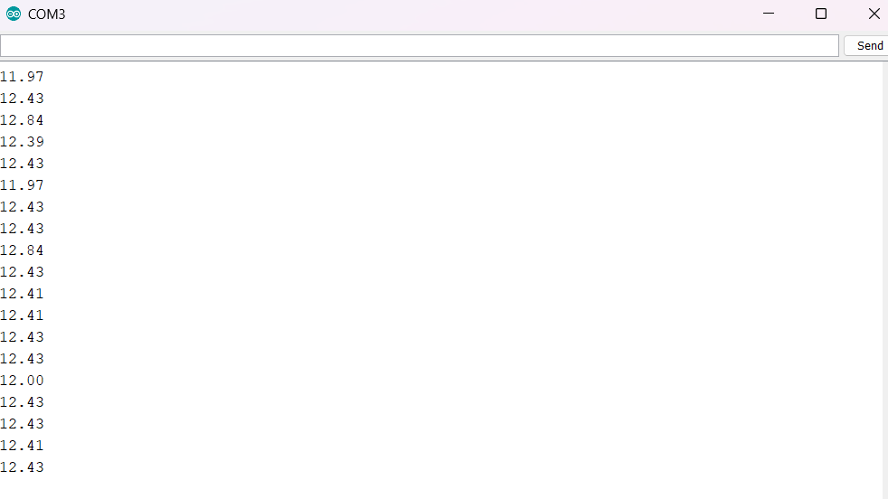

Figure 15. 1st water level test results

### The first test with no water should return h=8.9cm but here it returns 12cm. Here is due to ultrasonic impact with candle glue. To overcome this problem, we need to let the water level through the candle glue, the ultrasound will measure correctly. Of course, the pre-installed system under 400ml will warn the user to add water. At the same time, this water level is also past the candle glue, so there is no need to worry about this.

### The subsequent experiment aims to assess the precision of the sonographer's measurements. Pouring 1.1 liters of water, equivalent to a height of 4.9cm, the distance from the ultrasonic sensor to the water surface is 8.9-4.9=4cm.

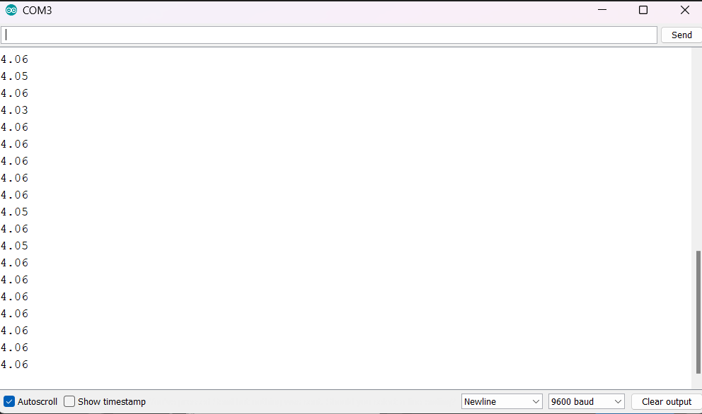

### Figure 16. 2nd water level test results

It is observed that the ultrasound readings are highly accurate. However, if more than 1.5 liters of water are poured, the ultrasound measurements may no longer be precise.

## 6.3 Remote control toy module

### 6.3.1 Circuit connection

Today, most of us keep cats indoors. Having some play equipment will help the cat become more active as well as create a connection between the owner and his pet. We improve a bit compared to some other common toys when users can control the toy through the app right on their smartphone instead of using a traditional controller.

Yellow geared motor will be used as a winch to pull or lower the toy as needed. It will be connected to the L298n circuit to communicate with the app. Users can then customize the toy rope according to their wishes. Camera is also applied to make the control easier as shown below.

Figure 17. Circuit map of Remote Control Toy

Usage is also very simple. Users only need to press the button through the Blynk app, the system will do its job.

**How remote control toy works**





Figure 18. Processing Flow of Remote Control Toy

### 

### 

### 

### 

### 6.3.2 Control function

The algorithm here is a bit simpler than the above two systems. Blynk will process data to raise and lower the cat toy through its on and off button.













TRUE FALSE









TRUE FALSE







Figure 19. Algorithm diagram of Remote Control Toy

### **6.3.3** Test and optimize

An iron shaft connects to the geared motor via a 5*8mm coupling, utilizing a rubber band from the cat toy for fastening. Activating the motor initiates controlled up and down movements of the rope. The subsequent explanation of the cat toy's functionality applies the winch's operational principle.

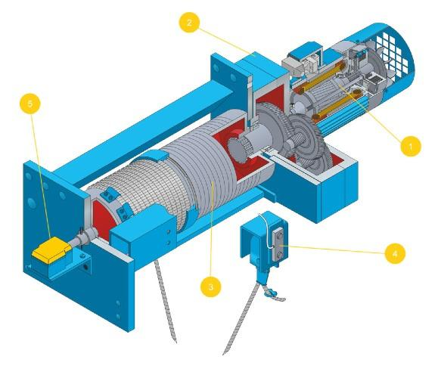

Figure 20. Principle of winch machine

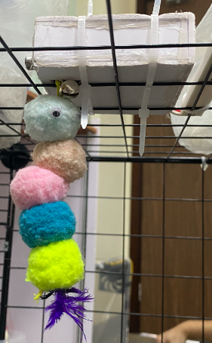

Figure 21. Equipment for cats to play

Rubber bands ensure cat-friendly play by preventing excessive motor strain and damage. This versatile and safe approach effectively creates engaging cat toys.

To establish optimal timing, durations are setted for lowering and raising the rope. It's essential to alternate the pulling direction during descent and ascent to avoid entanglement and ensure smooth retraction. After extensive testing, we determined a 10-second lowering time and a 9-second raising time.

The 1-second difference between lowering and raising accounts for the iron shaft's diameter change as the wire winds, influencing motion speed and timing.

These findings confirm the consistent and smooth operation achieved using the specified time intervals and elastic bands for pulling.

# 7. System Deployment

The whole operation is through the Blynk app, which collects all pet-related information with the sensor implemented in the Smart Cat Care System. The operating procedure and system diagram are shown in Figure 22 and Figure 23.

The devices mentioned so far have been implemented as shown in Figure 8. As shown in the figure, the selective feeding case is implemented with a spiral screw and plastic tube. The inside of the automatic feeding tray is divided into 2 layers for easy food storage. Stool pads are hard to come by with plastic tubes. Therefore, mica board is used to make the outer shell of the water system. Inside the box, a servo motor is used to pump water to the trough, and an ultrasonic sensor plays the role of monitoring the water level. In addition, motion sensors are also used to monitor the cat's movements so that the systems can be operated more smoothly.

Figure 22.Diagram of Smart Pet Care System

Here's how the system's algorithm works























Figure 23. System Algorithm Diagram

# 8. Control and monitoring application on the phone

## 8.1 Controls

Feeding or water intake history is recorded in the server and can be displayed via mobile web and smartphone APP. For these jobs, smartphone apps are devised.

The camera section on Blynk is just a video streaming test, so it only streams videos on the local network, so users can only connect to the camera with the local network to access it, so this is just a device integrated into the system to simulate observing cats when their owners are far away.

Users can log in with ID and password. Only administrators can change the IP settings of the feeder, pooping pad, and camera. The user can control the cat toy and can monitor the status of the water level as shown in Figure 24 and Figure 25

Figure 24. UI in Smart Pet Care APP

If the water level is more than 400 mml, a warning will be displayed on the Blynk app as shown in Figure 25

Figure 25.Water level warning on the Blynk app

## 8.2 Observe

Figure 26. Video from ESP32

# 9. Evaluation

The Smart Cat Breeding System has been thoroughly tested and evaluated. Through this process, we have found that this system brings many benefits and conveniences to the care and management of cats.

One of the prominent advantages of the system is its ability to provide a regular and customized diet. The system can be set up to provide the correct amount of food, ensuring the cat eats the right amount and at the right time remotely. Owners can observe the cat's health and receive notifications when there is an abnormality. This helps to preserve optimal nutrition for the cat.

The system also provides the possibility of entertainment with cats. The built-in motors allow the owner to remotely drop or collect the toy at any time via a mobile phone app. This not only makes the cat happier, but also increases interaction when the owner is forced to go away.

Remote interoperability is also an important advantage of the system. The owner can control and monitor the system via a mobile phone app from anywhere. This allows to create a safe and comfortable environment for the cat even when the owner is not at home.

However, it should also be emphasized that smart cat farming systems can require some technical knowledge and time for initial setup and configuration. In addition, the cost of the system can also be higher than that of traditional solutions.

Overall, the smart cat breeding system has proven its potential and usefulness in the care and management of cats. With the ability to provide a regular diet, monitor health and interact remotely, this system brings convenience and peace of mind to cat owners.

# 10. Conclusion and development direction

This article introduces a new smart pet care system based on IoT technology. As the number of single households increases, we can expect that the number of pet owners will increase. Nowadays we can see a lot of new devices being invented with the help of IoT. We believe that IoT can also change the existing structural model of the pet care system.

In this paper, we have proposed a new pet care system that can feed pets when the owner is away, and at the same time can observe their movements and state, and let them play with toys. through the owner's smartphone. The proposed system is different from others in that the proposed system is based on IoT technologies, using multiple sensors and wireless communication. Therefore, the proposed system is not limited in space and time only when providing wireless communication. However, we think we can expand the use of smart pet care systems along with the needs of pet owners. Another pet care device that can collaborate with existing devices is planned for future development. We believe we can create anything a pet owner wants.

In the future, the existing features of the project will be more complete and new features will be added such as using an automatic system to reduce the work of cat owners, the system can automatically provide food and water, clean the sandbox, and check the health. It can also send alerts to owners when there is an urgent problem or need for intervention. Support treatment if the cat has health problems, the system can provide instructions for first aid treatment and contact veterinarians/pet care centers to ask for help, etc. to complete into a more automated and intelligent system.

# 11. Project Plan management

| **Task Name** | **Priority** | **Owner** | **Status** | **Issues** |
| --- | --- | --- | --- | --- |
| **Coding read infrared sensor data** | **High** | **Nguyen Thuy Linh** | **Finished** |  |
| **Write slide content** | **High** | **Nguyen Thuy Linh** | **Finished** |  |
| **Slide design** | **High** | **Nguyen Thuy Linh** | **Finished** |  |
| **Writing system implementation** | **High** | **Nguyen Thuy Linh** | **Finished** |  |
| **Edit slides** | **High** | **Nguyen Thuy Linh** | **Finished** |  |
| **Coding relay** | **High** | **Truong Quoc Bao** | **Finished** | **Cover** |
| **Evaluate potential method** | **High** | **Truong Quoc Bao** | **Finished** |  |
| **Write a review of the experiment** | **High** | **Truong Quoc Bao** | **Finished** |  |
| **Design for cats to drink** | **High** | **Truong Quoc Bao** | **Finished** |  |
| **Feeding Design** | **High** | **Truong Quoc Bao** | **Finished** |  |
| **Find documents** | **High** | **Hà Quốc Việt** | **Finished** |  |
| **Data collection and labeling** | **High** | **Hà Quốc Việt** | **Finished** | **Safe** |
| **Writing system architecture** | **High** | **Hà Quốc Việt** | **Finished** |  |
| **Coding Esp32-camera** | **High** | **Hà Quốc Việt** | **Finished** |  |
| **Choosing device** | **High** | **Hà Quốc Việt** | **Finished** |  |
| **Write device structure** | **High** | **Hà Quốc Việt** | **Finished** |  |
| **Analyze and summarize related documents** | **High** | **Mai Van Tung** | **Finished** |  |
| **Writing appendix** | **High** | **Mai Van Tung** | **Finished** |  |
| **Writing abstract** | **High** | **Mai Van Tung** | **Finished** |  |
| **Writing introduction** | **High** | **Mai Van Tung** | **Finished** |  |
| **Write select Equipment** | **High** | **Mai Van Tung** | **Finished** |  |
| **Designed for cats to play** | **High** | **Mai Van Tung** | **Finished** |  |
| **Coding feeder functions** | **High** | **Ta Viet Duc** | **Finished** |  |
| **Coding cat playing** | **High** | **Ta Viet Duc** | **Finished** |  |
| **Write basic functions** | **High** | **Ta Viet Duc** | **Finished** |  |
| **Write algorithm diagram** | **High** | **Ta Viet Duc** | **Finished** |  |
| **Draw system principle diagram** | **High** | **Ta Viet Duc** | **Finished** |  |
| **Coding Calculator water function** | **High** | **Tran Viet Anh** | **Finished** |  |
| **Ultrasonic variable parameter adjustment** | **High** | **Tran Viet Anh** | **Finished** |  |
| **Infrared variable parameter adjustment** | **High** | **Tran Viet Anh** | **Finished** |  |
| **Write conclusion** | **Low** | **Tran Viet Anh** | **Pending** | **no contact** |
| **Write Camera and app Blynk** | **Low** | **Tran Viet Anh** | **Pending** | **no contact** |
| **Check actual parameters** | **Low** | **Tran Viet Anh** | **Pending** | **no contact** |
| **Write an experiment to measure the water level** | **Low** | **Tran Viet Anh** | **Pending** | **no contact** |

# 14.References

[1] [F. Mattern and C. Floerkemeier, “From the Internet of Computers to the Internet of Things”, Informatik- Spektrum, vol. 33, no. 2, **(2010)** , pp. 107-121.](http://google.com)

[2] [O. Vermesan and P. Friess, “Internet of Things-From Research and Innovation to Market Deployment”, River Publishers, **(2014)**](https://www.google.com.vn/?hl=vi) .

[3] APPEC, Asia Pacific Pet Economic Conerence, [http://www.2010appec.org.](http://www.2010appec.org/)

[4] Packaged Facts, *Pet care services in the US* ., 2nd Edition, Pub ID: LA 121907, 2006.

[5] Matthias Kranz, Paul Holleis, and Albrecht Schmidt, *Embedded Interaction Interacting with the Internet of Things, IEEE Internet Computing,* pp. 46-53, 2010.

[6] Gerd Kortuen, Fahim Kawsar, Daniel Fitton, and Vasughi Sundramoorthy, *Smart Objects as Building Blocks for the Internet of Things, IEEE Internet Computing* , pp. 44-51, 2010.

[7](Ericsson Mobility Report, 2016)

[8] Michael Rohs, Beat Gfeller, *Using Camera-equipped Mobile Phones for Interacting with Real-world Object, advances in pervasive computing, austrian computer society* , pp. 265-271, 2004.

[9] Matthias Kranz, Paul Holleis, and Albrecht Schmidt, *Embedded Interaction Interacting with the Internet of Things, IEEE Internet Computing,* pp. 46-53, 2010.

[10] Purina Website

[11]A. Muñoz-Prieto, LR Nielsen, . R. Dąbrowski, CR Bjørnvad, J. Söder, E. Lamy, I. Monkeviciene, . BB Ljubić, I. Vasiu, S. Savic, F. Busato, Z. Yilmaz, AF Bravo-Cantero, M. Öhlund, S. Lucena, R. Zelvyte, . J. Aladrović, P. Lopez-Jornet, M. Caldin, C. Lavrador, B. Karveliene, V. Mrljak, J. Mazeikiene and A. Tvarijonaviciute, "European dog owner perceptions of obesity and factors associated with human and canine obesity, " Scientific Reports, vol. 8, no. 1 p. 13353, 2018.

[12] K. PG, "Obesity as a medical problem," Nature, vol. 404, no. 6778, pp. 635-643, 2000.

[13] Americian Pet Product Association Inc., "Pet Industry Market Size, Trends & Ownership Statistics," https://www.americanpetproducts.org/press_indus trytrends.asp, 2021.

[14] "An Analysis of Pet-related Industries and Their Course of Development," Ministry of Agriculture, Food and Rural Affairs, Korea, 2016.

[15] Pet food manafacturer's association (PFMA), "Pet Obesity Ten Years On 2009 –2019," www.pfma.org.uk, London, 2019

[16]<https://www.researchgate.net/publication/370516496_Design_of_Smart_Prototype_Pet_Feeder_Using_Passive_InfaRed_PIR_Sensors>

[17]<https://www.researchgate.net/publication/366973324_SPF_Smart_Pet_Feeder_using_IoT_for_Day-to-Day_Usage>

[18]<https://www.researchgate.net/publication/340261266_IOT_based_Pet_Feeder>

[19]<https://www.researchgate.net/publication/360462586_Project_Title-Automatic_Pet_Feeder>

[20]<https://www.researchgate.net/publication/351505568_Smart_Pet_Feeding_Device_Based_on_Single_Chip_Microcomputer>